**Real-Time Mobile Messaging and Consumer Behavior in Malls: A Study**

**Shopco Project Report**

**Adithya Elakaturi**

**Chanukya Bolli**

**Jinsyben Pankajkumar Patodiya**

**Syeda Afreen Fathima**

**Course:** MGT585: Fundamentals of Business Analytics

Chicago, March, 2023

*(table of contents added and updated automatically with page numbers)*

Table of Contents

1. EXECUTIVE SUMMARY 3

2. OBJECTIVE AND QUESTIONS 4

2.1. Project purpose 4

2.1.1. Objective of the project 4

2.1.2. Questions 4

2.1.3. Experiment 4

3. DATA ANALYSIS AND RESULTS 4

3.1. Descriptive Analytics 4

3.2. Predictive Analytics 5

3.2.1. Regression Analysis 5

3.2.2. Clustering analysis 7

4. RECOMMENDATIONS AND CONCLUSION 9

# EXECUTIVE SUMMARY

The purpose of this document is to report on our findings of impact of real-time mobile messages on customer purchase behavior. In this experiment, the customers were randomly divided into two groups. The first group of 4516 customers received a real-time mobile message after their first purchase offering 1000 loyalty points if they made another purchase on the same day, regardless of the amount spent. The second group of 4516 customers did not receive any real-time message and continued their shopping without any intervention. The goal of the experiment is to determine if the real-time mobile message had any significant effect on the purchase behavior of the customers. Our findings showed that customers who received real-time messages had significantly higher sales from the second store onwards compared to the customers who did not receive the message. It can be concluded that real-time mobile messaging was effective as a means of outreach in advertising efforts. Therefore, it should be considered as a viable method for future advertising campaigns.

# OBJECTIVE AND QUESTIONS

## Project purpose

### Objective of the project

The objective of the project is to examine how the usage of real-time mobile messaging in a shopping mall impacts consumer’s inclination toward shopping.

### Questions

1. What is the impact of age on sales from the second store onwards?
2. What is the impact of real-time messages on sales from the second store onwards?
3. Which gender has relatively high loyalty status?

### Experiment

The mall operator conducted a field experiment on 9032 consumers that visited the mall during the week of Oct 1, 2019 in order to investigate the impact of real-time messages on consumer’s purchase behaviors. In the experiment 4516 consumers received a real-time message offering 1000 loyalty points if they make another purchase on the same day, while the other group of consumers did not receive any message.

# DATA ANALYSIS AND RESULTS

## Descriptive Analytics

There are 3 categorical variables and 2 continuous variables present in the datasets used in the shopco project.

* There are 6903 females and 2129 males within the categorical variable of “Gender”.
* There are 3269 low loyal and 5763 highly loyal consumers within the categorical variable of “Loyalty Status”.
* 50% of consumers received the real-time message while the other 50% did not receive the real-time message within the categorical variable of “Real-time Message”.
* The minimum, maximum, mean and standard deviation of the continuous variable age are 14 years, 66 years, 31.05 years and 9.34 years respectively.
* The minimum, maximum, mean and standard deviation from second store sales is 0 dollars, 1566 dollars, 34.65 dollars and 91.69 dollars respectively.

|  |  |  |  |
| --- | --- | --- | --- |
| Categorical Variables | | | |
| Variable | | Frequency distribution (number of consumers) | |
| Gender: Male | | 2129 | |
| Gender: Female | | 6903 | |
| Loyalty Status: 1 | | 3269 | |
| Loyalty Status: 2 | | 5763 | |
| Real-time Message: 0 | | 4516 | |
| Real-time Message: 1 | | 4516 | |
| Continuous Variables | | | |
| Variable | Mean | | Standard deviation |
| Age | 31.05 years | | 9.34 years |
| From second store sales | 34.65 dollars | | 91.69 dollars |

**Table 1: Descriptive analytics of the variables**

## Predictive Analytics

For predictive Analysis, We have conducted Regression Analysis and Clustering Analysis and gave a brief explanation of the results.

### Regression Analysis

For reg1, we are trying to predict sales from the second store using the age of the consumers. Here age of the consumers is the independent variable and sales from the second store onwards is the dependent variable. The results of the regression analysis are discussed below.

* The estimated column in the coefficients shows the estimated regression coefficients. Here, a=11.9675 and b=0.7307. The value of p for a and b coefficients is less than 0.05(p-value: a: p< 0.05; b: p< 0.05) which corroborates that we can ignore the null hypothesis.
* The adjusted R-square is 0.05435 which elucidates that 5.4% of sales from second store onwards is explained by age. F-static is 50.35 which is greater than 1.
* from_second_store_sales = 11.9675 + 0.7307(age) + e.

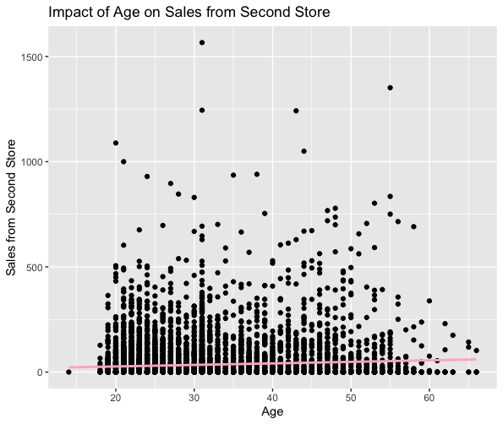

|  |  |  |
| --- | --- | --- |
| **Variable** | **Regression coefficient** | **Significance** |
| from_second_store_sales | a = 11.965 | p < 0.05 |
| age | b = 0.7307 | p<0.05 |

**Table 2: Results of the regression analysis**

For reg2, we are trying to predict sales from the second store using real-time messages sent to the consumers. Here real-time message is the independent variable and sales from the second store onwards is the dependent variable.The results of the regression analysis are discussed below.

* The estimated column in the coefficients shows the estimated regression coefficients. Here, a=32.578 and b=4.151. The value of p for a and b coefficients is less than 0.05(p-value: a: p< 0.05; b: p< 0.05) which corroborates that we can ignore the null hypothesis.
* The adjusted R-square is 0.0004016 which elucidates that 0.04% of sales from second store onwards is explained by real-time message. F-static is 4.629 which is greater than 1.
* from_second_store_sales = 32.578 + 4.151(realtime_message) + e.

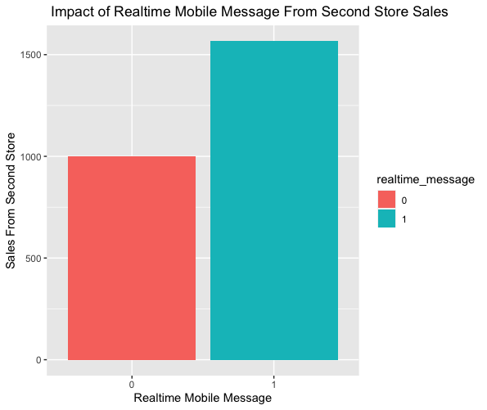

|  |  |  |
| --- | --- | --- |
| **Variable** | **Regression coefficient** | **Significance** |
| from_second_store_sales | a = 32.578 | p < 0.05 |
| realtime_message | b = 4.151 | p<0.05 |

**Table 3: Results of the regression analysis**

### Clustering analysis

The two features(independent variables) of the clustering analysis are “age” and “from_second_store_sales”. We set the number of clusters as 3 and nstart as 20.

* The sizes of clusters 1, 2 and 3 are 131, 967 and 7934 respectively.
* The clusters one, two and three can be profiled as clusters with low spending customers, moderately spending customers and high spending customers. The average age and average sales from the second store for the first cluster are 36.32 years and $566.53 respectively. The average age and average sales from the second store for the second cluster are 31.98 years and $176.9 respectively. The average age and average sales from the second store for the third cluster are 30.84 years and $8.53 respectively.
* The within cluster variation of the three clusters are 5859048, 4940865 and 3884392.
* Clusters of consumers intention to keep shopping Y {Cluster1, Cluster2, Cluster3} = f(From second store sales, Age)

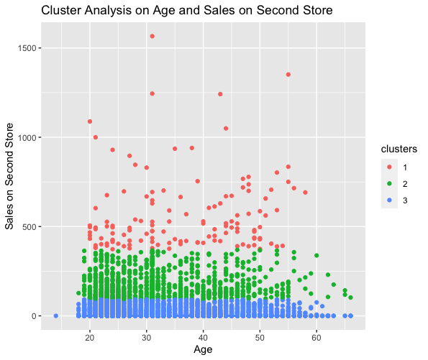

# RECOMMENDATIONS AND CONCLUSION

The consumers between 20 to 50 years old spent more on sales from the second store onwards and it is significantly higher for consumers who received the real-time message compared to those who didn't receive the real-time message. The female consumers have high loyalty status as compared to the male consumers.

The managers must make sure that more consumers receive the real-time message as those who received it spent more money. The managers must invest more money into their loyalty programs in order to retain more consumers and also to increase their purchases. The managers must also make more investments into real-time messaging targeting female consumers as they are much more active shoppers compared to males according to the data analyzed.